Coordinate Algebra
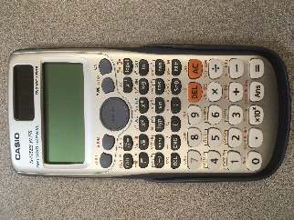
- Binder
- Paper – College Ruled
- Graph Paper
- Dividers (5)
- Pencils (Mechanical or Wooden)
- Erasers
- Stylist
- Flash drive (at least 2 GB)
- Casio fx-115ES PLUS (Recommended over TI brand)

Analytic Geometry
- Math Compass
- Protractor
- Ruler
- Graph paper
- Lined paper college ruled
- Expo markers
- Pencils (mechanical or wooden)
- Colored pencils
- Highlighter assortment for notes
- Glue stick
- Stylist
- Flash drive (at least 2 GB)
- Casio 115-ES (or higher) or TI-30 (or higher) calculators ($10-$16, NOT graphing)
- 1 Composition notebook

Advanced Algebra or Advanced Mathematical Decision Making
- 1 Composition Notebook
- Paper College Ruled
- Folder
- Dividers
- Binder (1-2” recommended)
- Pencils (mechanical or wooden)
- Markers/Colored Pencils
- Stylist
- Flash drive (at least 2 GB)
- Casio 115-ES (or higher)/TI-30 (or higher) calculators OR Graphing (TI BRAND ONLY)
*Graphing calculator recommended if student is planning a career in sciences/maths/computers/medical/engineering/etc.

Pre-Calculus or Accelerated Pre-Calculus
- Paper College Ruled
- Dividers
- Binder (1-2” recommended)
- Pencils (mechanical or wooden)
- Markers/Colored Pencils
- Stylist
- Flash drive (at least 2 GB)
- Graphing Calculator TI-84 and higher (TI BRAND ONLY)

AP Calculus
- Paper College Ruled
- Dividers
- Binder (1-2” recommended)
- Pencils (mechanical or wooden)
- Markers/Colored Pencils
- Stylist
- Flash drive (at least 2 GB)
- Graphing Calculator Ti-84 and higher (TI BRAND ONLY)

AP Statistics and Statistics
- Paper College Ruled
- Dividers
- Binder (1-2” recommended)
- Pencils (mechanical or wooden)
- Markers/Colored Pencils
- Colored Pens (at least 3 different colors)
- Small Sticky Note Tabs
- Stylist
- Flash drive (at least 2 GB)
- Graphing Calculator Ti-84 and higher (TI BRAND ONLY)

